## TASK 1:

Identification of the peripherals of a computer, components in a CPU and its functions. Draw the block diagram of the CPU along with the configuration of each peripheral.

**INTRODUCTION TO COMPUTER:**

Computer is an electronic device which takes the input information from the input device and generates the output information and it will be displayed on the output.

It enables arithmetic computations, data processing, information management (storage) and knowledge reasoning in an efficient manner.

The word computer is derived from the word **compute which means „to calculate‟.** So a computer generally considered to be calculating device that perform operations at very faster rates.

## BLOCK DIAGRAM OF COMPUTER

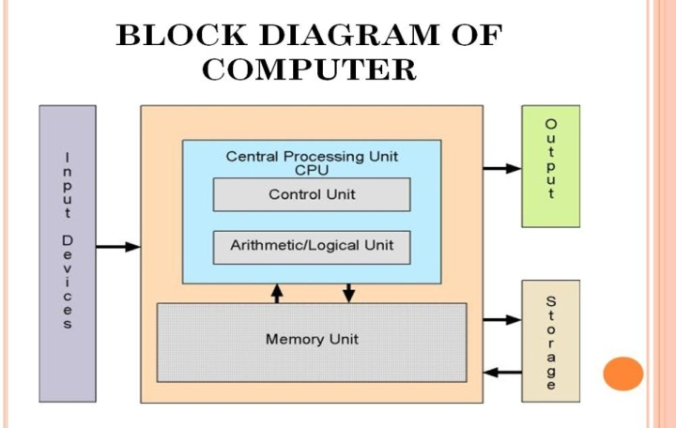

Basically the computer system has three major components. These are

* SystemUnit
  + Central Processing Unit(Processor)
  + Memory Unit. (Main memory and Auxiliarystorage).
* InputUnit.
* Output Unit.

## Motherboard

The *motherboard* is hardware that makes connections between all of the other components in a computer

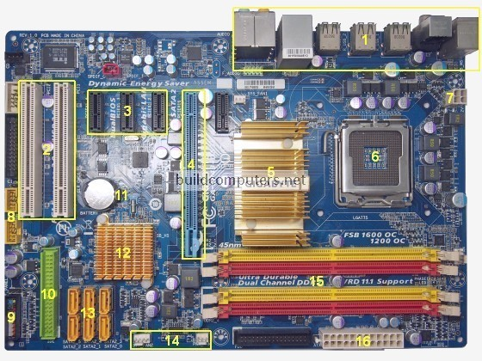

### Procedure:

1. **Cabinet:**
   1. It is used to install all hardware devices like(mother board, SMPS, HDD,CD ROM,FDD)

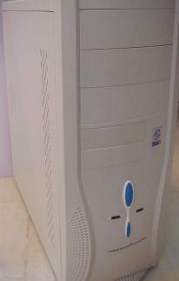

PowerLED

PowerSwitch

HDDLED

ResetSwitch

Cabinet

* 1. It has Start, Restart Button, Led‟s, Audio and USB Connecters are available at frontside.

### Monitor:

* 1. Monitor of a computer is like a televisionscreen.
  2. It displays text characters and graphics in colors or in shades of grey.
  3. The monitor is also called as screen or display or CRT (cathode ray tube). In the monitor the screen will be displayed in pixelsformat.
     1. 800 by 600pixels
     2. 1024 by768pixels .

### KeyBoard:

* 1. Key board is like a type writer, which contains keys to feed the data or information into thecomputer
  2. Keyboards are available in two modules. Theseare
     1. standard key board with 83-88 keys

d. 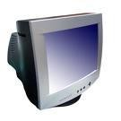

* + 1. 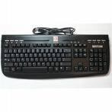enhanced key board with 104 keys orabove

### Mouse:

* 1. Every mouse has one primary button (left button) and one secondary button (rightbutton).
  2. The primary button is used to carry out most tasks, where as secondary button is used in special cases you can select commands and options

### Printer:

* 1. A device that prints images (numbers, alphabets, graphs, etc…) on paper is known asPrinter.
  2. We have different types of printers to take printouts. These are asfollows:

1. Dot matrix printer

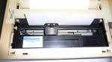

### Speakers:

* 1. Speakers make your system much more delightful to use entertain you while you are working oncomputer

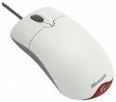

1. Inkjet printer

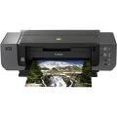

1. Laser printer

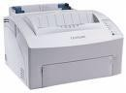

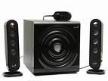

### http://t3.gstatic.com/images?q=tbn:wb4bC-mu2WLreM%3Ahttp://www.library.drexel.edu/blogs/thesuggestionbox/Scanner.jpgScanner:

* 1. Scanner used to scan images andtext

### Systemboard/Motherboard

* 1. This is the major part of the PC hardware

Mother Board

* 1. It manages all transactions of data between CPUperipherals.
  2. which holds the Processor, RandomAccess Memory and other parts, and has slots for expansioncards
  3. It isrectangleshape e.

### Socket478:

* 1. 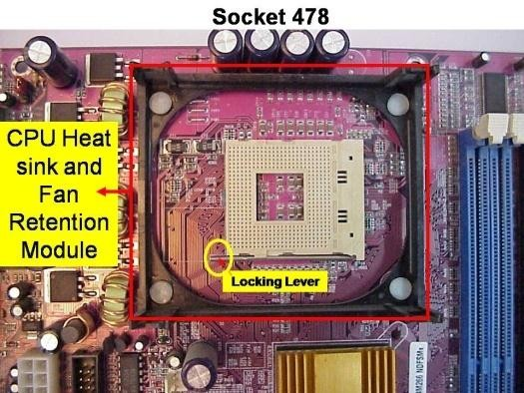It use 478 – PIN MICROPGA package it is used installingCPU
  2. It is square typedesign.

### CPU

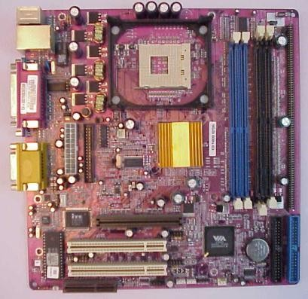

* 1. The central processing unit contains the heart of any computer, the

processor. The processor is fitted on to a Mother Board. The Mother

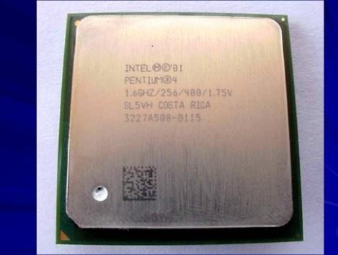Board contains various components, which support the functioning of a PC.

* 1. It is brain of thecomputer
  2. It is squareshape

.

### Ram Slots andRams:

* 1. 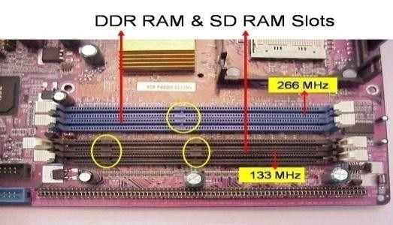Ram slots are used to install therams
  2. It is large rectangle shape and each ending has smallclips.
  3. There two type ramslots
  4. SDRam; →TwoGaps
  5. DDRRam →OneGap

f.

g. 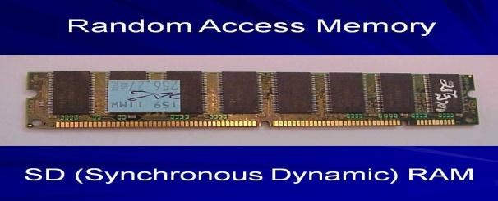

### NorthBridge:

* 1. 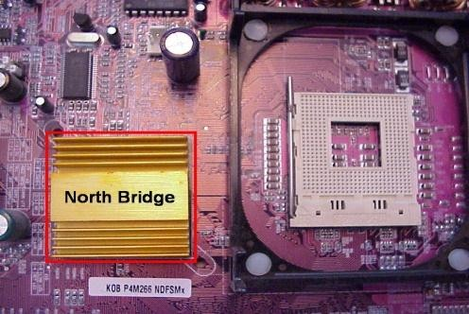It is also called ascontroller
  2. It converts electronic signals to binary values and binary values to electronicsignals
  3. It is near by socket478
  4. It placed middle of the motherboard

### SouthBridge:

* 1. 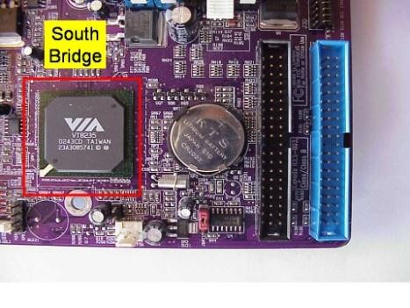It is controls major components mother board and it back bone of the input outdevices
  2. It is communicates PCI slots, IDE-1, IDE-2, floppy connecter, BIOSchip.
  3. It near by CMOSbattery

### Slide18CMOS Battery:

* 1. Computer is using a coin shape battery
  2. It generates the clock signal and it manage system continuestime

### Primary & Secondary(IDE-1 & IDE-2):

* 1. 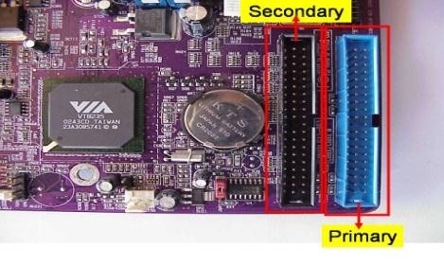It is also called as IDE-1,IDE-2.
  2. It used to connecting Hard Disk Dive, CD ROM, DVDROM.

c.

### Input & Out put ports:

* 1. IO ports are used to connecting IO device such as key boards, mouse, monitor, printer, scanner, speakers etc...

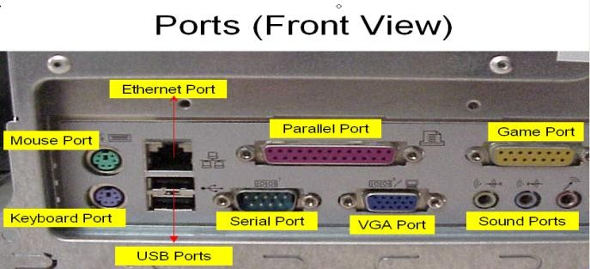

### AGP Slot & AGP Card:

* 1. AGP Slot is used install the AGPcard.
  2. AGP back view same as VGA port(15-female pins) and used to connecting the monitors
  3. This slot is above PCI slots and its color is Black or Brown

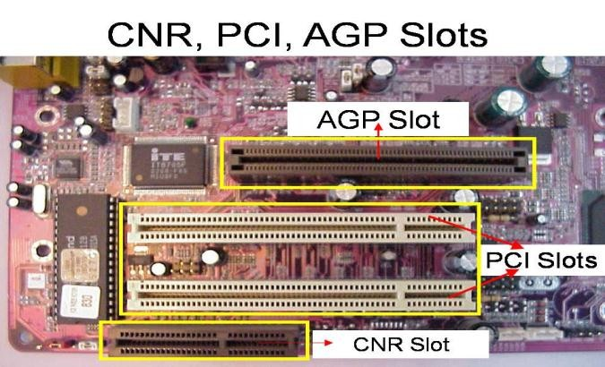 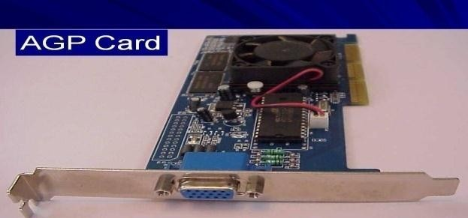

### CI Slots &PCI(Expansion) Cards:

* 1. PCI slots are used to install the PCI cards suchas

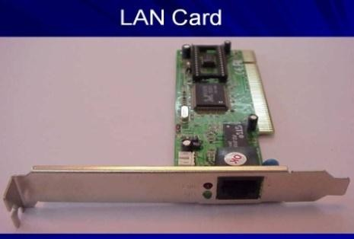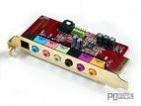

* + 1. LAN (Ethernet) Card---→Back view Ethernetport
    2. Sound Card-→ Back view Audio pinconnectors)
    3. TV Tuner(Internal) Card -→ Dish Pinconnecter 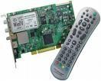
  1. PCI Slots are white or yellowcolor
  2. PCI Card has Single gaponly

### BIOS Chip :

* 1. BIOS controls how the operating system and hardware woktogether
  2. BIOS identification is BIOS name is available on chip or motherboard

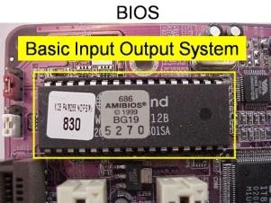c.

### ATX Power connecter:

* 1. 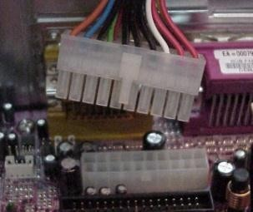ATX power connecter is used to connect ATX power plug( This is fromSMPS)
  2. ATX Power connecter has 20/24 pinsavailable.
  3. It is white color and it has ATXname is available on MotherBoard

d.

e.

### Floppyconnecter:

* 1. 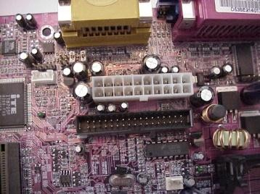Floppy connecter is used to connect Floppy DiskDrive.
  2. This is beside of ATX power connecter and Name FDD is available on the motherboard.

### Bus Cables or Data cables:

* 1. 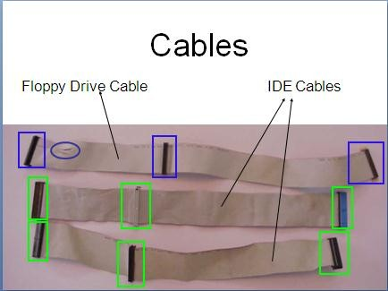A Bus is a collection of wires through which data is transmitted from one device to another device cables are twotypes
  2. IDE cable : it used to connect HDD,CD ROM, DVDROM
  3. FDD cable: it used to connect FDD (braking or manufacturedefecting)

### Hard DiskDrive:

* 1. The hard disk drive is the main, and usually largest, data storage device in acomputer
  2. The operating system, software titles and most other files are stored in the hard diskdrive
  3. Identifications is the panel name is Hard Diskdive

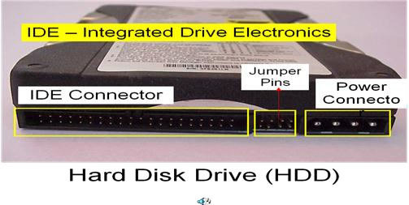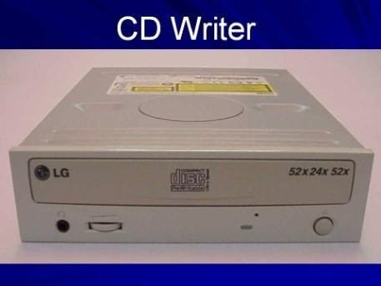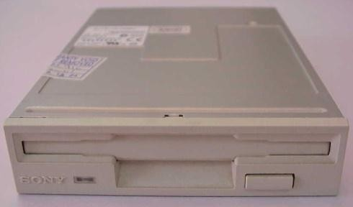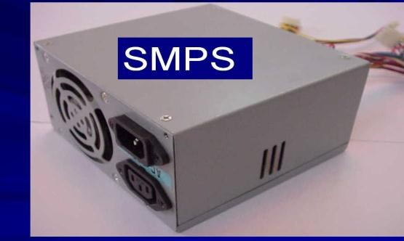

### CD ROM Drive &CD-Writer:

* 1. CD-Rom (Compact Disk Read only Memory) Drive is a device that reads the information from Compact Disks (CD).
  2. CD-Writer is used to write the data into CompactDisks.
  3. Identification is the panel name is CD Writer

### Floppy DiskDrive:

* 1. The floppy disk drive is used to read the information stored in floppy disks.
  2. Floppy disks also called as a diskette.
  3. Identification is smaller than CD writer.

### SMPS:

* 1. SMPS is used to supply the power to Mother Board HDD,CD ROM,FDD
  2. In SMPS holds a transformer, voltage control andfan
  3. Identification is the rectangular box shape and panel name is switching mode powersupply.

**TASK 2**

**Aim:** Assembling and disassembling the system hardware components of the personal computer

### Requirements:

1. CPU(Processor)
2. MotherBoard
3. Floppy DiskDrive
4. Hard DiskDrive
5. CD or DVDROM
6. Cabinet
7. Speakers
8. KeyBoard
9. Mouse
10. Monitor
11. RAM( SD orDDR)
12. BusCables
13. PowerCables
14. SMPS
15. ScrewDriver
16. Screws
17. Printeretc…

### Procedure:

1. **Mother BoardInstallation:**

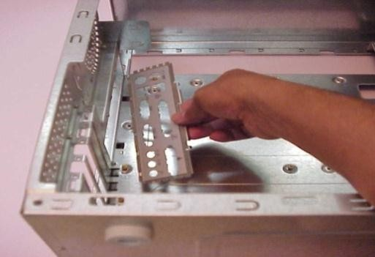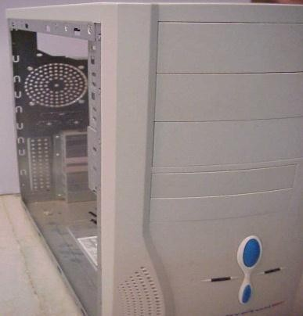

* 1. Open the cabinet on eitherside.
  2. The back side of the cabinet has readymade provision for the installation of the I/O shields. An I/O shield is used for connecting the input and output devices throughit.

C. Check whether the mother board is placed in such a way that the I/O ports of the motherboard correctly fit in the I/O shields. Ensure all the specified screws for the motherboard are fixed and intact.

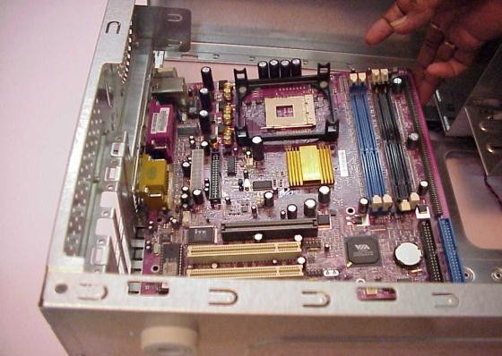 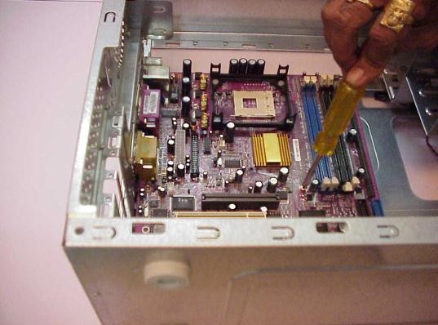

### CPU Installations:

1. CPU is one of the most dedicated components of the computer. The CPU pins have to be clearly studied before fixing into the relevant processor space onthe

motherboard. After the CPU is rightly placed in its position the lever is to be locked.

12

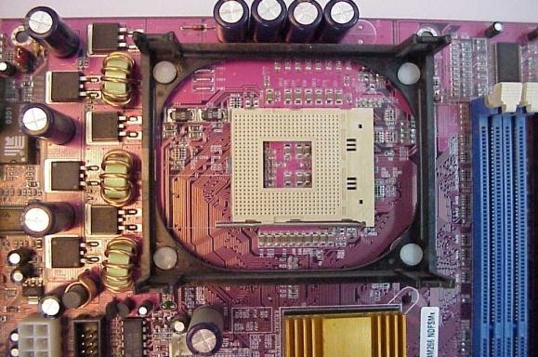

1. As a part of the CPU installation, before the CPU is fixed in the right position a lever is provided, which needs to be unlocked. This lever is perpendicular to themotherboard.

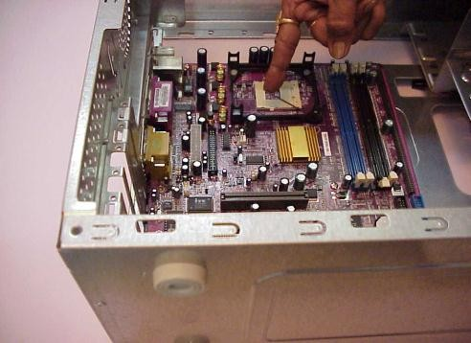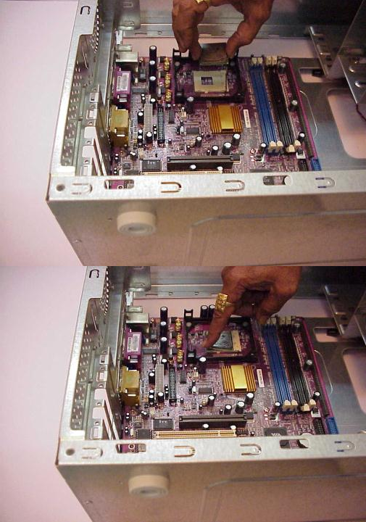

1. The CPU, which is a square shaped electronic component, comes with pinsbelow it. One should find for an indication on one of the corners of the CPU on both sides. This arrow mark is also found on the motherboard which guides for the fixation of the CPU. Once match of the pins verses motherboard slot gently push theCPU.
2. After the CPU is rightly placed in its position, the lever is to belocked.

### MVC-301LCPU heat sink fan installation:

1. The CPU heat sink fan is to be carefully plugged on to the CPU by pushing down the metal plasticclips.
2. The metal/plastic clips provided with heat sink fan should fix on to the CPU socket and have to belocked.

13

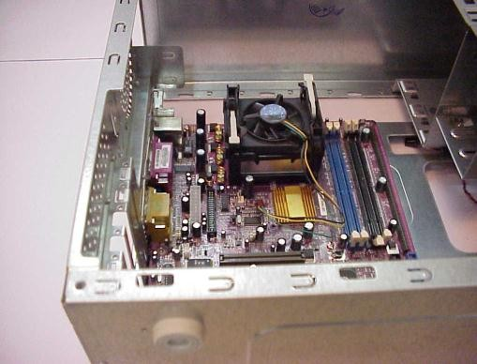

1. 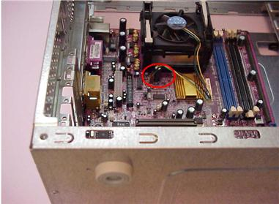Once the CPU het sink fan is fixed and locked, it should be connected to the Power supply available on the mother board through the powerconnector.

### RAM Installation:

1. Next is installing the RAM. Insert the RAM into an available expansion socket. Note how the RAM is keyed to the socket. This ensures the RAM can be plugged into the socket one way only. Finally press the RAM firmly into position, making certain the Ram is completely seated in thesocket.

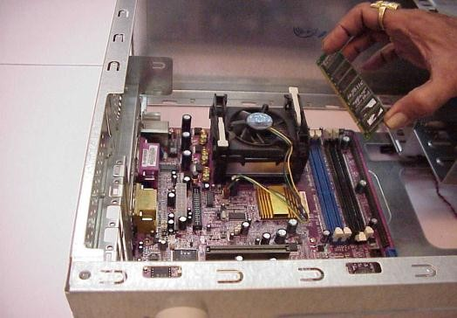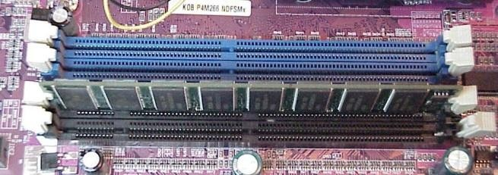

### SMPS Installations:

1. Next is installing the SMPS. This is an electronic power supply unit that provides and regulates the power supply to all components of a computer system. As shown in the diagram the SMPS needs to install into cabinet at the place provided forit.
2. After placing the SMPS into the relevant provider space fix the outer screws to itintact.

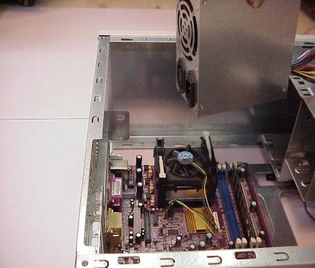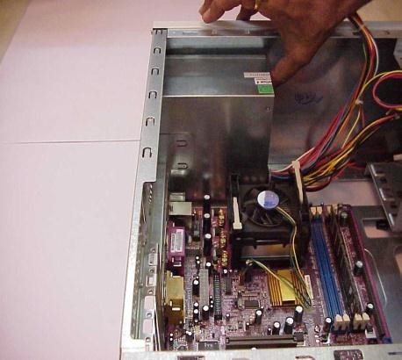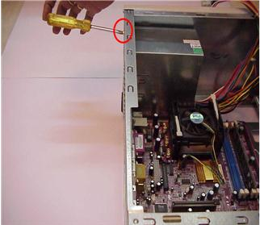

1. Next installing the ATX power connector. It is a 20/24-pin power connector. This is the primary power supply to the motherboard.

14

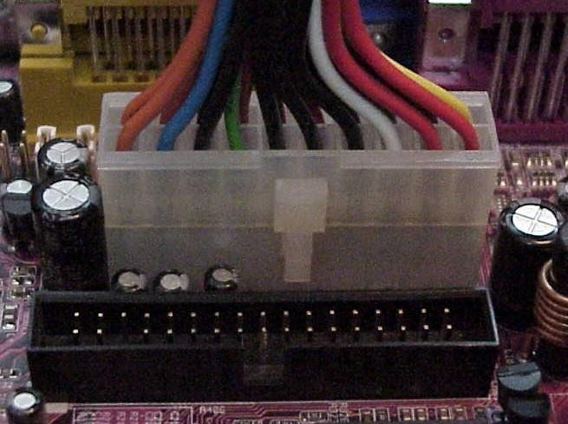

### Hard Disk Drive Installation:

1. Installing the Hard Disk Drive (HDD) is clearly understood in the following steps. First see the rare of the HDD. It consists of the 3 types of pins. One left side the HDD has multiple pins termed as the IDE connector. In the middle is the jumper setting pins for the HDD. On the extreme right side is the power connector pins. Every device except FDD (floppy Disk Drive) uses this type of power connector. And HDD and CDD (Compact Disk Drive) connected by this type of IDEcable.

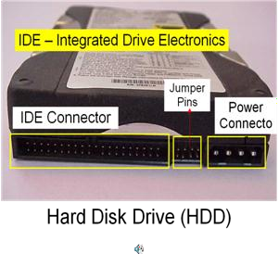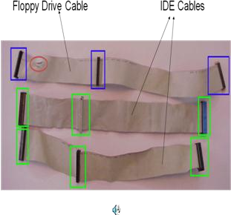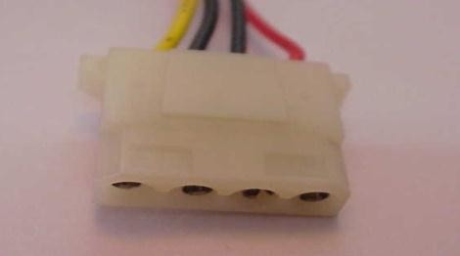

Power Connector

1. Mount the HDD into mounting slot meant for the HDD with the rear end facing and secure the inner screwsintact.

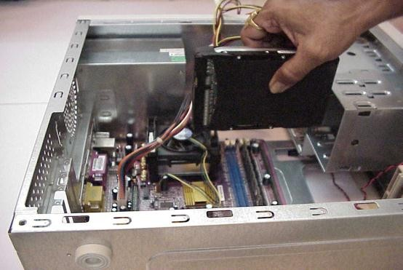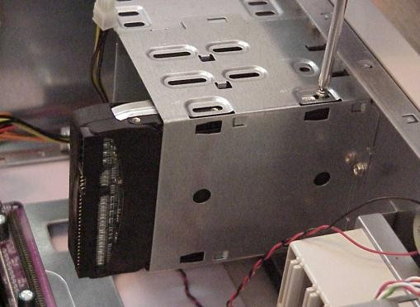

1. Connect the IDE cable to the HDD as well as the mother board as shown in thefigure.

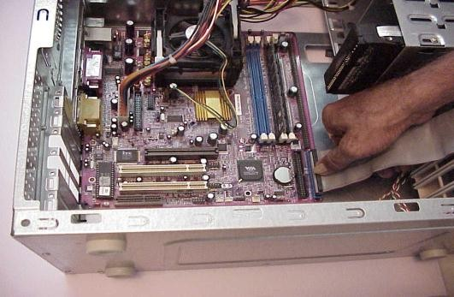 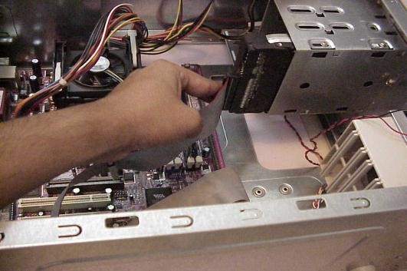

1. Remember for all the power connectors to be plugged in, one needs to align the Red line on the cable to Pin-1 of the IDE port. Henceconnectthepowercabletothe

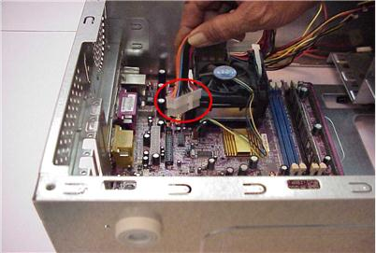

HDD rare end by gently pushing the connector.

15

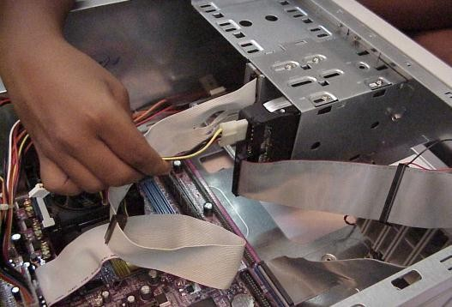

### Floppy Disk Drive Installation:

1. Installation of a Floppy Disk Drive (FDD) is very similar to the HDD installation. We need to identify the relevant pins for the motherboard and power supply connectivity. First Step in the FDD installation is mounting of the FDD into the FDD mounting slot by removing the cover of front side of the cabinet as shown in the figurebelow.
2. Push the FDD case into opened of the cabinet curtaining of theFDD

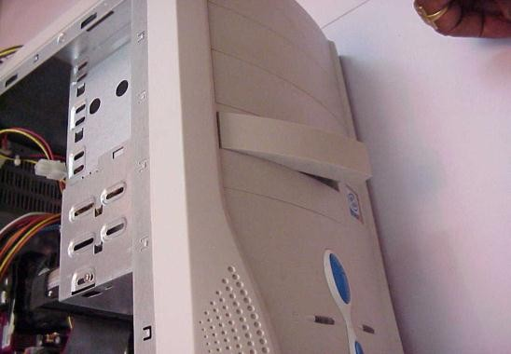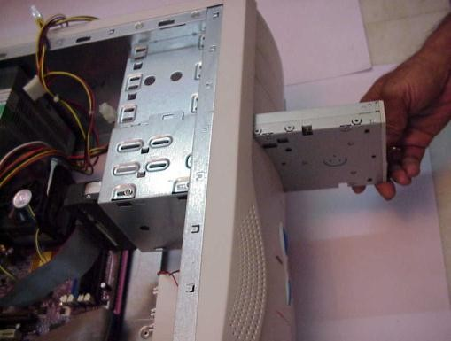

1. Secure FDD with innerscrews.

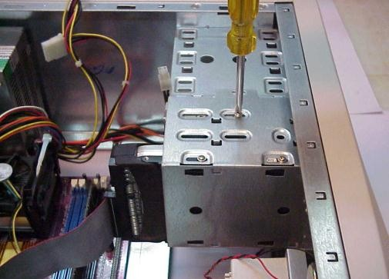

1. Connect the one end of cable to mother board and other to end toFDD.

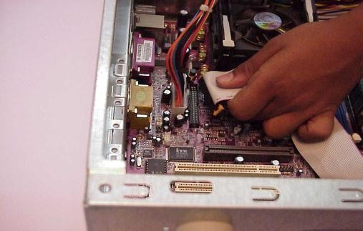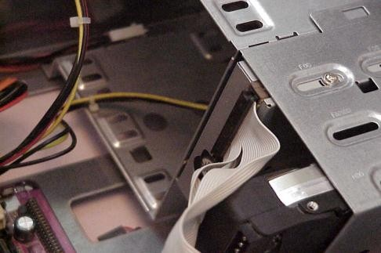

1. Connect the power connector to theFDD.

16

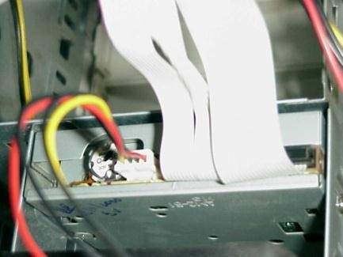

### CD ROM Installation:

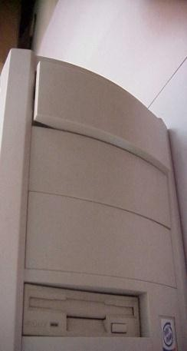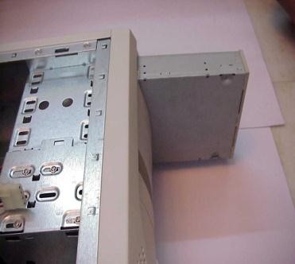

1. Next installing the CD-ROM. Remove the cover of front side of the cabinet curtaining of theCD-ROM.
2. Push CD-ROM case into openedspace.
3. 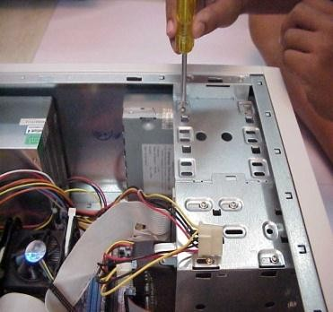Secure CD-ROM with innerscrews.
4. Connect the one end of cable to motherboard and another end toCD-ROM.

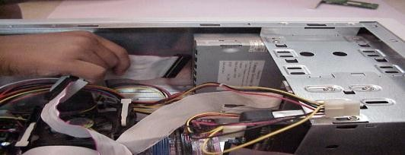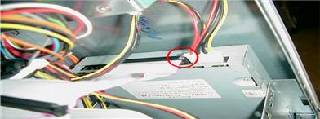

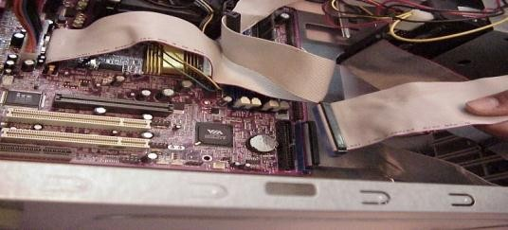

1. Connect the power connector to the CD- ROM.

17

### Switches and LEDs Connections:

1. Installing the Switches and LEDs of front side of the cabinet. Please refer to your mother board manual to locate where the connectors are. Different mother boards place the connectors in different locations. The connectors for the switches and LEDs are normally grouped together. They should look similar to the figure givenbelow.

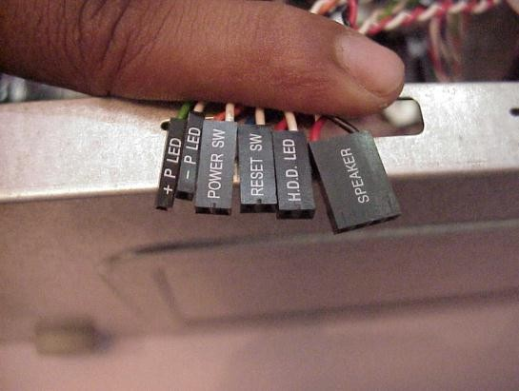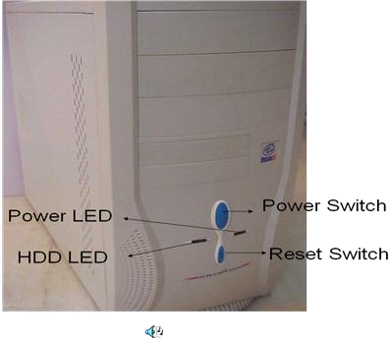

### IO Devices Installations:

1. Finally connect all peripheral devices like mouse, key-board, monitor, etc, to the I/O ports shown in the figurebelow.

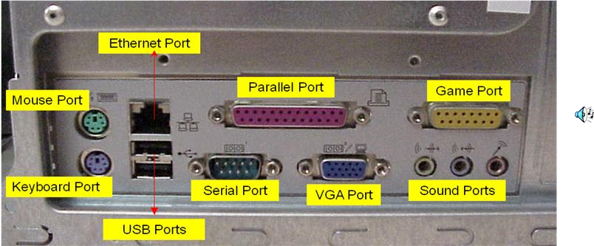

### Keyboard:

Keyboard has round shape connectors. The male connector appears at the edge of the keyboard‟s cable and the female connector appears at the back side of the system unit. We are using the 6 pins round keyboard connector.

### Mouse:

The mouse connector is same as the keyboard connector. The male connector appears at the edge of mouse cable and female connector appears at the backside of the system. It is also having 6 pins to connect themouse.

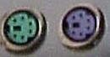

### Monitor:

Themonitorofcomputerhas„D‟shapeconnectors.ThemaleMonitorconnectorhas15pinsandit appears at the edge of monitor‟s cable. The female monitor connector appears at the back of the systemunit.

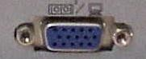

### Printer:

Printer connector is the oldest connector of a computer. The male printer connector has 25 pins and it appears at the edge of the printer cable and the backside of the system unit.

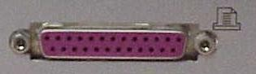

### Audio /Speaker:

For audio effect we are using speakers. The audio male connector have single thick pin and each male connector of individual speaker is distinguish with separate color. The male connectors appear at the edge of the speaker cables. The female audio connectors appear in same color at the back side of the system unit. The female audio connectors have some special symbolsi.e.

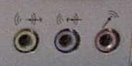

* 1. The first symbol displays“line-out”.
  2. The second symbol displays“line-in”.
  3. The third symbol displays“Mic-in”.

Line-out → it sends the out put tospeakers.

Line-in → it takes the input fromspeakers.

Mic-in → it takes the input frommicrophone.

### Ethernet /Networking:

The Ethernet connectors are used when two or more than two computers need to be linked with other over a computer network like LAN (local area network). The shape of male Ethernet connector is quite similar to male modem connector except it is more flat. The female Ethernet connector appears at the back of the systemunit.

### USB:

USB (universal serial bus) is the latest and most popular connector. Using USB connectors, we can connect so many different devices to our computer. Any device equipped with USB has slim male connector with slim metal coating appearing at the end of the devices cable. For connecting the device, a female USB connector is provided at the back of the system unit. We can identify the USB connector with this symbol.

### USB: Ethernet/Networking: